## Press Release

**swop – Shanghai World of Packaging 2015:**

**Shaping Up to be the Most Influential Exhibition in Packaging Industry**

**2015.08.18** With just 3 months leading up to the inaugural 4 in 1 exhibition **swop – Shanghai World of Packaging**, up to now, more than 600 companies in the packaging industry from Germany, the United States, Japan, Turkey, Korea, China and other countries and regions have confirmed their participation. Organized by Adsale Exhibition Services Ltd, Messe Düsseldorf (Shanghai) Co Ltd, and China Center for Food and Drug International Exchange (CCFDIE), swop will take place from 17 – 20 November, 2015 at Shanghai New International Expo Centre (SNIEC), PR China.

**PacPro Asia 2015** is one of the 4 professional exhibitions of **swop - Shanghai World of Packaging.** It will showcase cutting-edge machinery and process technologies for all kinds of packaging solutions, including materials such as paper, plastics, metals, glass, wood, ceramics and textiles. This year, **swop** cooperates with the “Packaging Family” to present the **"Packaging Material Zone"** at **PacPro Asia**. It is an excellent opportunity for end-users to experience the latest achievements in packaging materials. The new zone sets a star studded debut, with nearly 200 leading companies joining to display their latest technologies and developments, including Shanghai Packaging and Paper (Group) Co. Ltd, Jielong Printing, F. S. Korea, HCT, Fedrigoni etc. One of the biggest household appliances manufacturers in the world Haier will also be bringing their packaging suppliers to the zone!

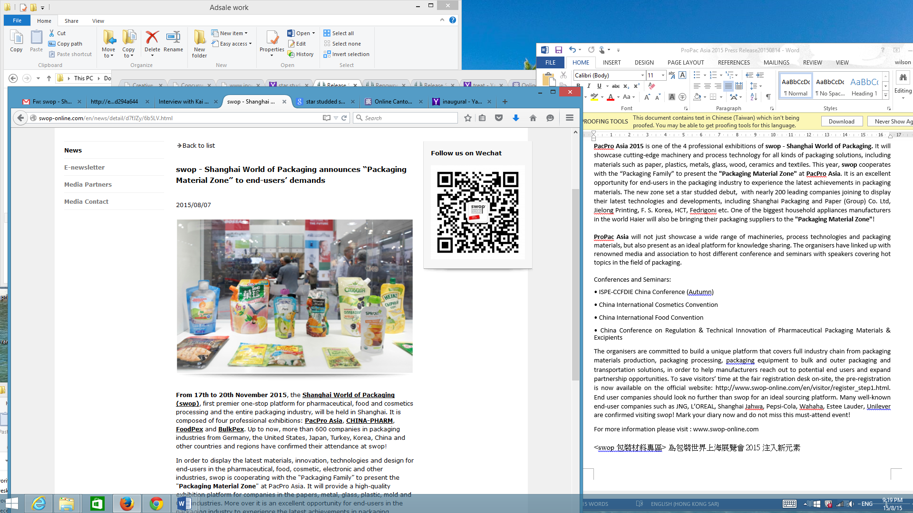

**swop 2015** will not just showcase a wide range of packaging machinery, materials and process technologies, but also presents as an ideal platform for knowledge sharing. The organizers have linked up with renowned media and associations to host different conferences and seminars with speakers covering hot topics in the field of packaging.

Conferences and Seminars include:

• Haier’s supply chain management new model

• Future of packaging from the needs of brands

• ISPE-CCFDIE China Conference (Autumn)

• China International Cosmetics Convention

• China International Food Convention

The organizers are committed to build a unique platform that covers full industry chain from packaging materials production, packaging processing, packaging equipment to bulk and outer packaging and transportation solutions, in order to help manufacturers reaching out to potential end users and expanding partnership opportunities. Those looking for the latest achievements in packaging industry cannot afford to miss **swop**. Many well-known end-user companies such as JNG, L’OREAL, Shanghai Jahwa, Pepsi-Cola, Wahaha, Estee Lauder, Unilever etc have confirmed to visit swop! Mark your diary now and do not miss this must-attend event!

To save visitors’ time from on-site registration, the pre-registration is now available on the official website: <http://www.swop-online.com/en/visitor/register_step1.html>.

-End-

For more information, please visit [www.swop-online.com](http://www.swop-online.com)

About the Organizers:

**China Center for Food & Drug International Exchange (CCFDIE)**

China Center for Food and Drug International Exchange, as an independent institutional legal person, is a public institution affiliated to the China Food and Drug Administration (CFDA). By centering on the functions and work priorities of CFDA, CCFDIE undertakes international exchanges and cooperation through non-governmental channels, organizes and implements international exchange and cooperation programs among enterprises, scientific research institutions, social organizations, foundations as well as foreign institutions.

**Messe Düsseldorf Shanghai Co., Ltd (MDS)**

Messe Düsseldorf Group is ranked among the TOP 5 Trade Show organizers worldwide. Messe Düsseldorf (Shanghai) Co. Ltd., the subsidiary of Messe Düsseldorf GmbH, is committed to introducing Düsseldorf world’s no. 1 trade fairs to China. Since being established, MDS has successfully organized B2B trade fairs in Mainland China for the following industries: printing, packaging, wire & tube, plastics, renewable energy, medical devices, safety& health, wine & spirits and caravanning.

**Adsale Exhibition Services Ltd. (Adsale)**

Adsale possesses over 35 years of staging international exhibitions in China and has become one of the leading companies in this field. Adsale is the organizer of Chinaplas exhibition which is Asia’s no.1 plastics and rubber trade fair. Adsale’s Sino-Pack, Printing South China and Sino-Label exhibitions also have over 20 years’ track record.

Contact Information:

China Center for Food and Drug International Exchange (CCFDIE)

Ms. Hao Bin

Tel: +86-10-8221 2866

Email: [haobin@ccfdie.org](mailto:haobin@ccfdie.org)

Messe Düsseldorf (Shanghai) Co Ltd

Ms. Bella Wan

Tel: +86-23-8860 5906

Email: [bella.wen@mds.cn](mailto:bella.wen@mds.cn)

Adsale Exhibition Services Ltd

Ms. Winnie Fung

Tel: +852-2516 3389

Email: [printpack.hkpr@adsale.com.hk](mailto:printpack.hkpr@adsale.com.hk)

 **Please send us a specimen copy if you publish this text. Thank you!**